Analysis report carried out on four subjects (musical instruments, graphic design, business finance and web development) offered at the Education Tech Company Udemy.

Project description
The manager, Head of curriculum at Udemy requested data on course revenue. The company wants to know where opportunities to increase revenue may lie and also to track performance of courses.

Data design
The data for the four different subjects; musical instrument, graphic design, business finance and web development was presented. The data was cleaned by removing duplicates and blank cells. The data was then analyzed using Google sheets, pivot tables and Tableau public.

Findings from the data

- Comparing Subject and the total number of subscribers
Comparing the total number of subscribers for the various courses, it could be seen that Web development courses has the highest number of subscribers followed by Business finance, Graphic design and then musical instruments.
Table 1.0
Business Finance | 1868711
Graphic Design | 1063148
Musical Instruments | 846689
Subject: Web Development | 7981935
Grand Total | 11760483

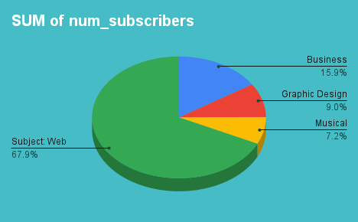

Table 1.1 comparing Subject versus average number of subscribers

subject | AVERAGE of num_subscribers
Musical Instruments | 1,245.1
Business Finance | 1,569.0
Graphic Design | 1,766.0
Subject: Web Development | 6,635.0
Grand Total | 3,199.3

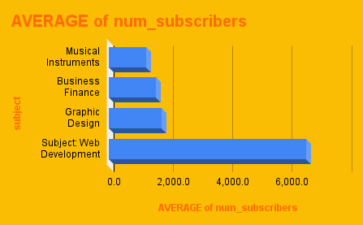

- Comparing cost per subject at each level
When the number of subscribers is compared to the price, it can be seen that the paid courses has the highest number of subscribers compared to the free courses. Web development courses have the highest number of paid subscribers and also the highest number of free subscribers, followed by business finance, Graphic designs and then Musical instrument.
Table 1.2 Comparing cost per subject at each level
AVERAGE of price | level
subject | All Levels | Beginner Level | Expert Level | Intermediate Level | Grand Total
Business Finance | 70.2 | 68.7 | 65.8 | 62.0 | 68.7
Graphic Design | 62.1 | 50.7 | 28.6 | 59.4 | 57.9
Musical Instruments | 49.6 | 49.0 | 48.3 | 51.6 | 49.6
Subject: Web Development | 74.5 | 78.5 | 67.1 | 85.1 | 77.0
Grand Total | 66.8 | 65.2 | 58.0 | 66.9 | 66.1
SUM of num_subscribers | IF function
subject | free | paid | Grand Total
Business Finance | 603,228.0 | 1265483 | 1868711
Graphic Design | 284,821.0 | 778327 | 1063148
Musical Instruments | 304,735.0 | 541954 | 846689
Subject: Web Development | 2,393,767.0 | 5588168 | 7981935
Grand Total | 3586551 | 8173932 | 11760483

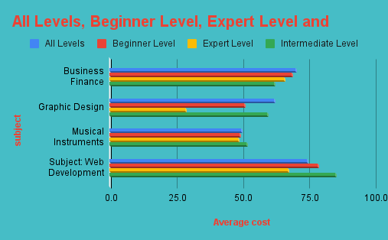
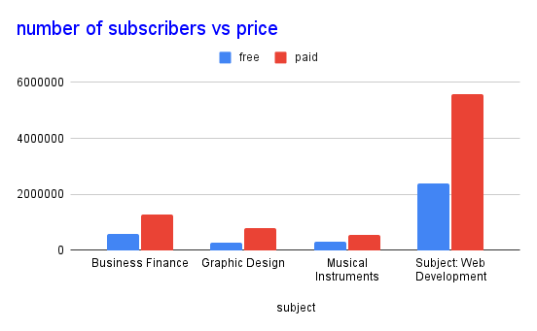

- Average rating per subject for each level
In the rating received for each of the subjects on all the levels, Graphic Design received the highest rating followed by Business Finance, Web Design and then Musical Instruments.
Table 1.3
Average rating per subject for each level
level
All Levels | Beginner Level | Expert Level | Intermediate Level | Grand Total
0.69 | 0.69 | 0.70 | 0.70 | 0.69
0.73 | 0.73 | 0.88 | 0.72 | 0.73
0.31 | 0.31 | 0.30 | 0.28 | 0.31
0.65 | 0.64 | 0.50 | 0.67 | 0.64
0.62 | 0.60 | 0.59 | 0.62 | 0.61

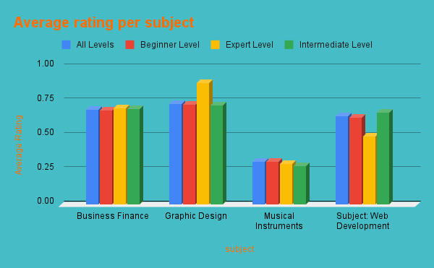

- Average content duration of each subject
Web Development courses have the highest content duration followed by Graphic Design, Business Finance and then Musical Instrument.
Table 1.4
AVERAGE of Rating | level
subject | All Levels | Beginner Level | Expert Level | Intermediate Level | Grand Total
Business Finance | 0.69 | 0.69 | 0.70 | 0.70 | 0.69
Graphic Design | 0.73 | 0.73 | 0.88 | 0.72 | 0.73
Musical Instruments | 0.31 | 0.31 | 0.30 | 0.28 | 0.31
Subject: Web Development | 0.65 | 0.64 | 0.50 | 0.67 | 0.64
Grand Total | 0.62 | 0.60 | 0.59 | 0.62 | 0.61

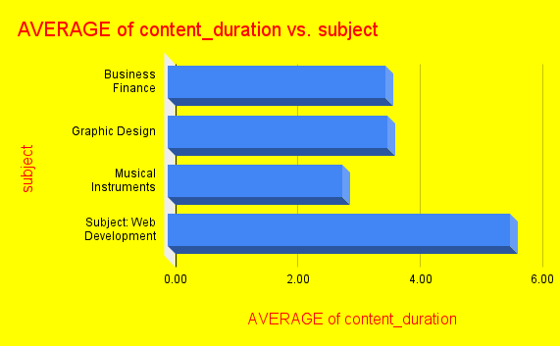

Virtual representation of the data from Tableau.

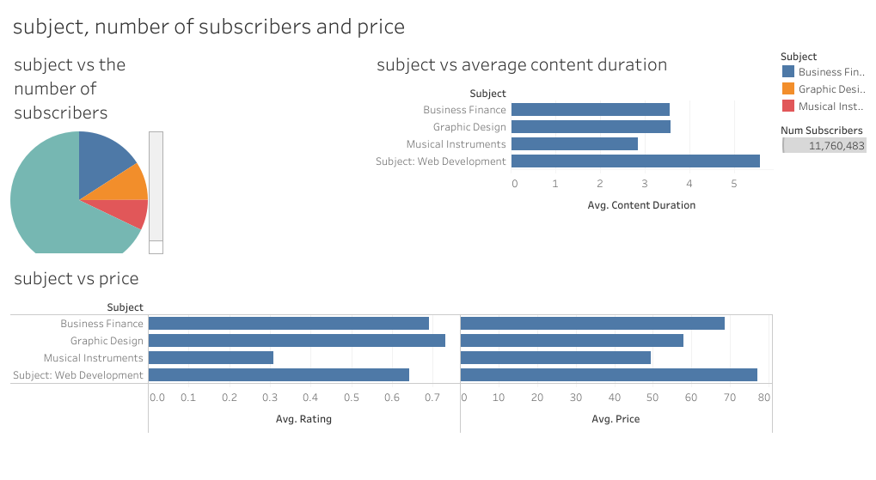

Analysis of the data
Why does the company require increase in revenue? Revenue is needed for the smooth running of the organization.
Why are some courses free and others paid? Some courses are free probably because they needed to be made known to the public first. Then from there, track the performance.
Why do the web development courses have the highest number of subscribers compared to others subjects?
Web development courses have the highest number of subscribers because it is very popular and very high in demand. It is followed closely by Business Finance, Graphic design and then musical Instrument. The population is in order of popularity.
Why do the paid courses have more subscribers than the free courses?
From the analysis of the data presented, web development courses have the highest number of subscribers and generated overall highest revenue. But the revenue it generated is low compared to the number of subscribers for each of the courses offered on the subject. It can practically be said that Business Finance, graphic Design and Musical Instrument generated more revenue than Web Development even though their number of subscribers is not up to half of the total number of subscribers for the Web Development courses. Also, judging from the comparison between the number of subscribers for the free and paid courses, it will be safe to say that the number of subscribers is independent of price as the paid courses have the highest number of subscribers compared to the free courses across the whole subjects.
Why do the graphic design courses have the highest rating?
When it comes to rating, It is expected that the Web development courses should receive the highest average rating because of its number of subscribers but it was not so. Graphic Design received the highest average rating followed by Business Finance. Why is this so? Could it be because of the high course duration that many are not able to complete the courses? Or is it from the method of communicating the knowledge to the subscribers? This actually shows that Graphic Design and Business Finance courses have better performance compared to web Development and Music Instrument courses. Web Development could be expected to perform better not just because of its population but also because it is popular and very high in demand (which is obviously why they have the highest number of subscribers) and hence should have the capacity to generate higher revenue.

Conclusion
In conclusion, the performance of the free courses should be properly evaluated and then revenue allocated to them according to their performances. There should be a way to make rating compulsory so as to get accurate performance of the courses. More revenue should also be allocated to the web Development courses but it should be done with subtlety. There should be something like demo topics for the free courses and then payment to complete the course. The demo topics should be loaded with irresistible value so as to make the subscriber unable to resist. Or a course, especially those with high content duration should be broken down into stages, free stage and paid stage instead of being entirely free. The performance will be properly monitored and proper action taken. This should also be done for all subjects. There should be a level of commitment from the subscribers. Only newly introduced courses should be free depending on the demand for them and revenue could be allocated later to them if their performance is good.

